

NAME OF THE PROJECT

**Flight Price Prediction**

Submitted by:

Ram Kumar

**ACKNOWLEDGMENT**

I have taken efforts in this project. However, it would not have been possible without the kind support and help of many individuals. We would like to extend my sincere thanks to SME. Khushboo Garg .

We are highly indebted to Flip Robo technology for their guidance and constant supervision as well as for providing necessary information regarding the project & also for their support in completing the project.

I thanks and appreciations also go to our colleague in developing the project and people who have willingly helped us out with their abilities.

Thanks all.

Ram kumar

.

**INTRODUCTION**

* Anyone who has booked a flight ticket knows how unexpectedly the prices vary. The cheapest available ticket on a given flight gets more and less expensive over time. This usually happens as an attempt to maximize revenue based on –
* 1. Time of purchase patterns (making sure last-minute purchases are expensive)
* 2. Keeping the flight as full as they want it (raising prices on a flight which is filling up in order to reduce sales and hold back inventory for those expensive last-minute expensive purchases)
* So, you have to work on a project where you collect data of flight fares with other features and work to make a model to predict fares of flights.

**Analytical Problem Framing**

Import library and load the dataset:

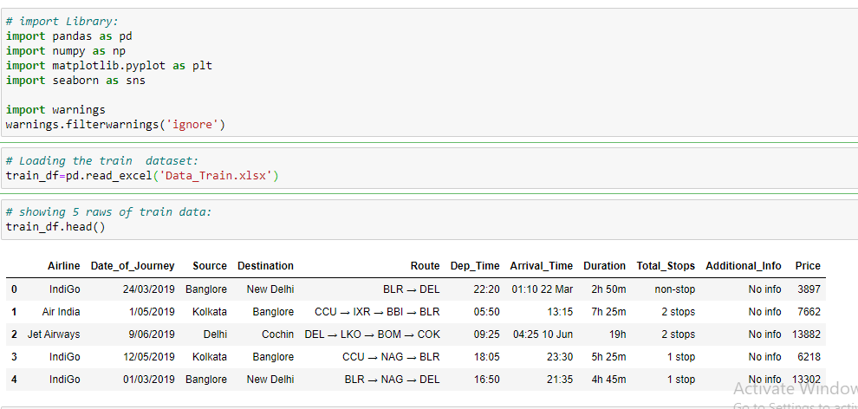

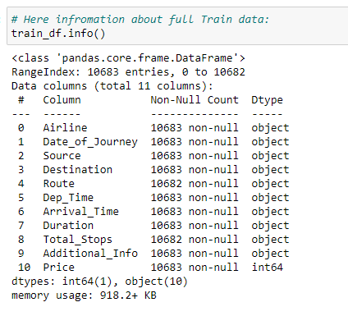

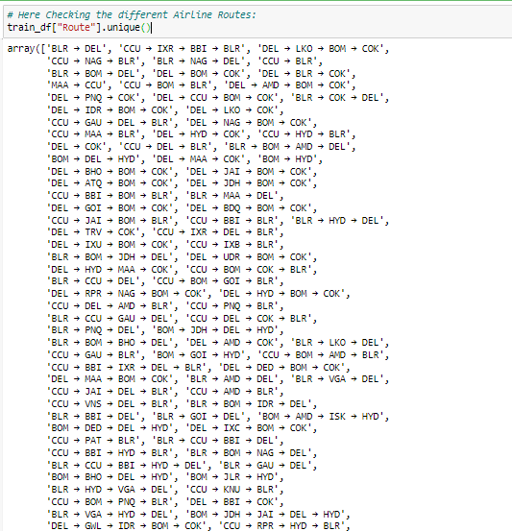

* Display all column name of dataset.

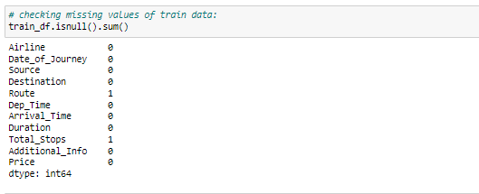

* Display statistical summary.

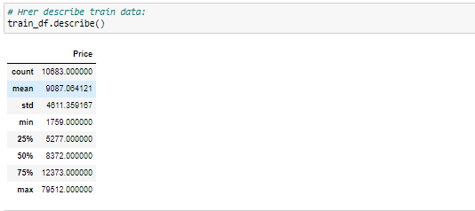

* Display histplot of all columns.

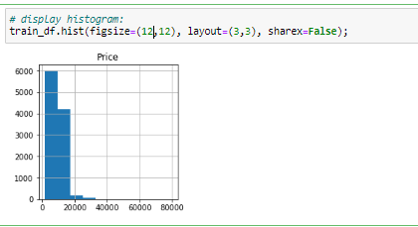

* Display correlation of columns using heatmap.

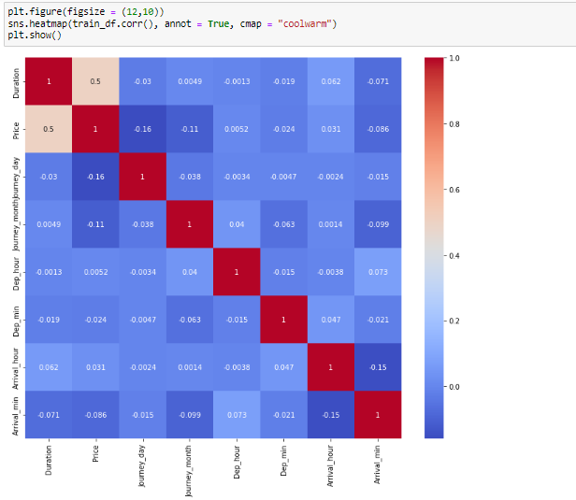

* Display countplot of all columns.
* 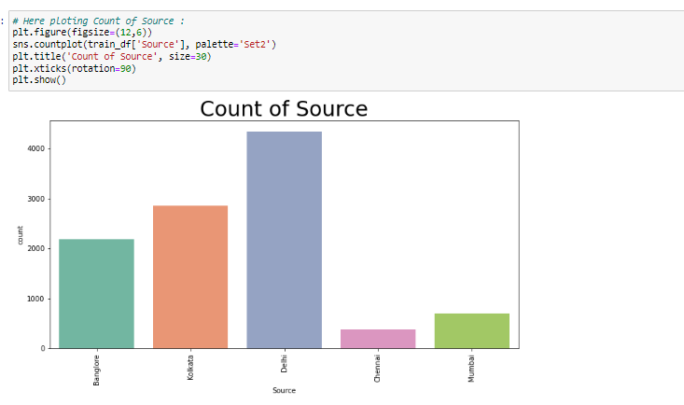
* Display barplot of all columns 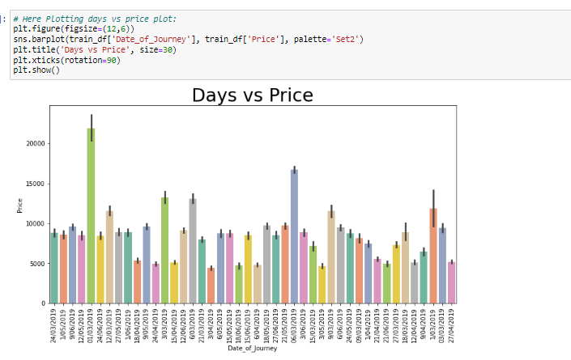
* Display countlot of all columns :

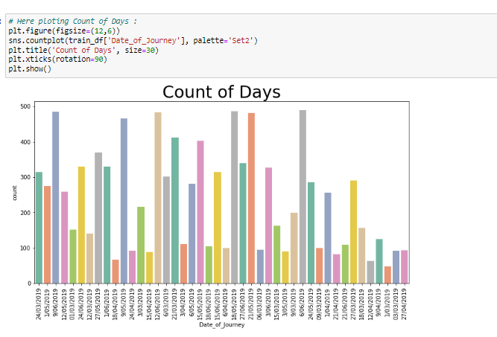

**Model/s Development and Evaluation**

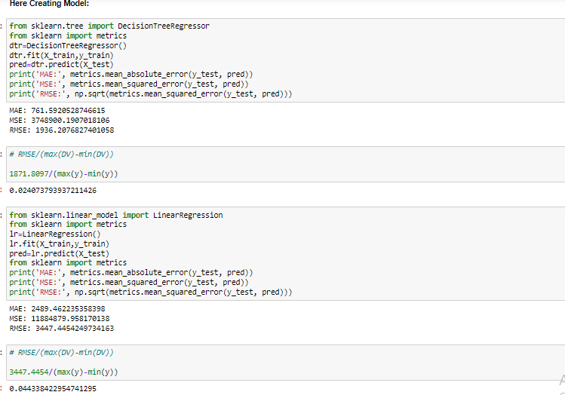

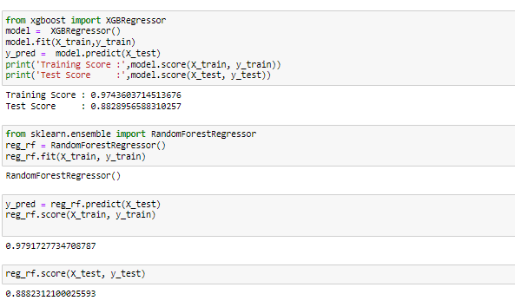

**Testing of Identified Approaches (Algorithms):**

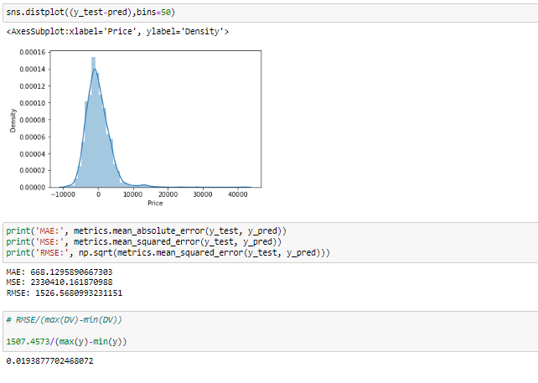

**Run and Evaluate selected models**

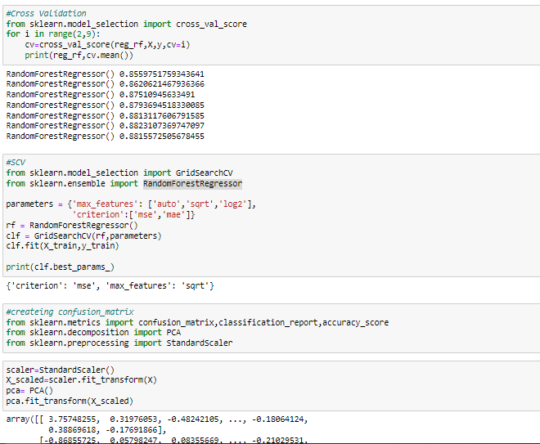

* **Hypertuning the model** :

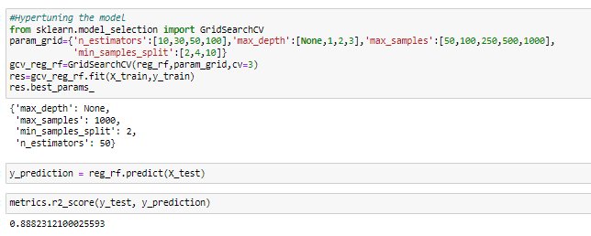

* Flight Price test and predicted data

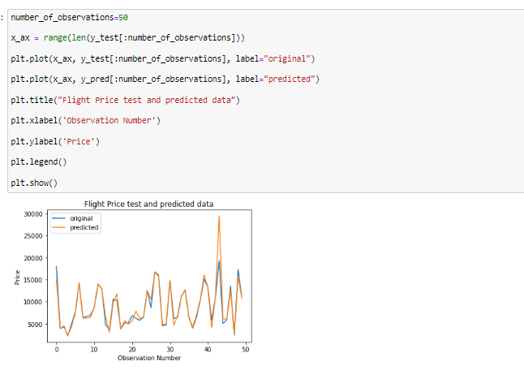

* Hardware and Software Requirements and Tools Used
* **Language :-** Python
* **Tool:-** Jupyter
* **OS:-** Windows 10
* **RAM:-** 8gb

**CONCLUSION**

 the machine learning models in the computational intelligence feild that are evaluated before on different datasets are studied. their accuracy and performances are evaluated and compared in order to get better result. For the prediction of the ticket prices perfectly differnt prediction models are tested for the better prediction accuracy. As the pricing models of the company are developed in order to maximize the revenue management. So to get result with maximum accuracy regression analysis is used. From the studies , the feature that influences the prices of the ticket are to be considered. In future the details about number of availble seats can improve the performance of the model.